**3-1 Milestone: Database Indexing and Authentication**

Aaron Ciminelli

SNHU

CS-340-T3341 Client/Server Development 23EW3

Hari Paruchuri, Adjunct Professor (M.S, MBA)

January 22, 2023

1. Import CSV file, db “AAC” and collection name “animals” using mongoimport:

--headerline is only for CSV or TSV

mongoimport --port 39040 --db AAC --collection animals --type CSV --headerline --file ./aac_shelter_outcomes.csv

1. Create a Simple Index
   1. on the key “breed”.

> db.animals.createIndex({breed:1})

* 1. example explain function

to get a list of all breeds (for explain function)

> db.animals.distinct(“breed”)

> db.animals.find({“breed”:“Siberian Husky”).explain(“allPlansExecution”)

> db.animals.find({“breed”:”Siberian Husky”}).explain(“queryPlanner”)

1. Create Compound Index:

> db.animals.getIndexes() // checking for existing indexes

> db.animals.createIndex({breed: 1, outcome_type: 1, Transfer: 1}) // creating compound index

> db.animals.getIndexes() // verifying index was added

Use explain function

> db.animals.find({“outcome_type”: “Transfer”, “breed”: 1)}.explain()

1. Create admin account

> use admin // admin database

> db.getUsers() // checking to make sure no accounts exist

> db.createUser(

… {

… user: “myUserAdmin”,

… pwd: “admin”,

… roles: [ { role: “userAdminAnyDatabase, db: “admin”}, “readWriteAnyDatabase”]

… }

… )

> db.getUsers() //verify admin was added

> db.adminCommand( { shutdown: 1} )

5. Enable user Authentication

$ mongo –authenticationDatabase “admin” – u “myUserAdmin”

Enter Password: admin

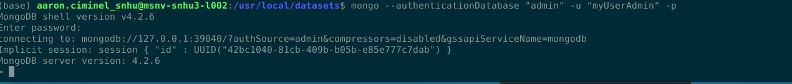

6. Create user account “aacuser” in AAC database

> use AAC

> db.createUser(

…{

…user: “aacuser”,

…pwd: “password”,

…roles: [ { role: readWrite”, db: “text”},

…{role: “read”, db: “reporting”}]

…}

…)

> db.getUsers() // verify user was added

